9) Create a React Application named “cricketapp” with the following components:

1. ListofPlayers

* Declare an array with 11 players and store details of their names and scores using the map feature of ES6

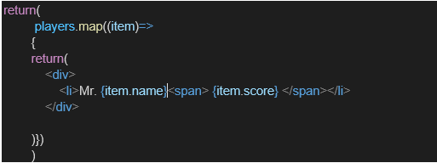

* Filter the players with scores below 70 using arrow functions of ES6.

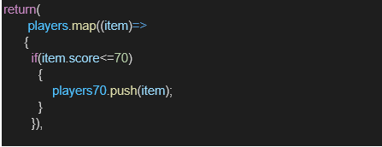

1. IndianPlayers

1. Display the Odd Team Player and Even Team players using the Destructuring features of ES6

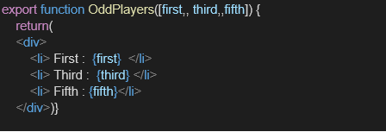

1. Declare two arrays T20players and RanjiTrophy players and merge the two arrays and display them using the Merge feature of ES6

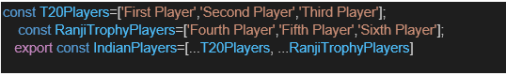

Display these two components in the same home page using a simple if else in the flag variable.

ListOfPlayers.js:

import React from 'react';

const ListofPlayers = () => {

   const players = [

    { name: 'Jack', score: 50 },

    { name: 'Michael', score: 70 },

    { name: 'John', score: 40 },

    { name: 'Ann', score: 61 },

    { name: 'Elisabeth', score: 61 },

    { name: 'Sachin', score: 95 },

    { name: 'Dhoni', score: 100 },

    { name: 'Virat', score: 84 },

    { name: 'Jadeja', score: 64 },

    { name: 'Raina', score: 75 },

    { name: 'Rohit', score: 80 },

  ];

  const playersBelow70 = players.filter(item => item.score <= 70);

  return (

    <div className="p-4">

      <h2 className="text-2xl font-bold mb-4 text-gray-700">List of Players</h2>

      <ul className="list-disc list-inside mb-8">

        {}

        {players.map((item, index) => (

          <li key={index} className="mb-1 text-gray-600">

            Mr. {item.name}: <span className="font-semibold">{item.score}</span>

          </li>

        ))}

      </ul>

      <h2 className="text-2xl font-bold mb-4 text-gray-700">List of Players with Scores Less than 70</h2>

      <ul className="list-disc list-inside">

        {}

        {playersBelow70.map((item, index) => (

          <li key={index} className="mb-1 text-gray-600">

            Mr. {item.name}: <span className="font-semibold">{item.score}</span>

          </li>

        ))}

      </ul>

    </div>

  );

};

export default ListofPlayers;

IndianPlayers.js:

import React from 'react';

const IndianPlayers = () => {

  const teamPlayers = ['Virat Kolhi', 'Rohit Sharma', 'KL Rahul', 'Hardik Pandya', 'Ravindra Jadeja', 'Jasprit Bumrah', 'Mahendra Singh Dhoni'];

  const [oddPlayer1, , oddPlayer3, , oddPlayer5] = teamPlayers;

  const oddTeamPlayers = [oddPlayer1, oddPlayer3, oddPlayer5];

  const [, evenPlayer2, , evenPlayer4, , evenPlayer6] = teamPlayers;

  const evenTeamPlayers = [evenPlayer2, evenPlayer4, evenPlayer6];

  const T20Players = ['Rishabh Pant', 'Suryakumar Yadav', 'Ishan Kishan'];

  const RanjiTrophyPlayers = ['Ruturaj Gaikwad', 'Shivam Dube', 'Shreyas Iyer'];

  const allIndianPlayers = [...T20Players, ...RanjiTrophyPlayers];

  return (

    <div>

      <h1>Indian Players</h1>

      <h2>Odd Players</h2>

      <ul>

        {oddTeamPlayers.map((player, index) => (

          <li key={index}>{player}</li>

        ))}

      </ul>

      <h2>Even Players</h2>

      <ul>

        {evenTeamPlayers.map((player, index) => (

          <li key={index}>{player}</li>

        ))}

      </ul>

      <h2>Combined List of Indian Players</h2>

      <ul>

        {}

        {allIndianPlayers.map((player, index) => (

          <li key={index}>{player}</li>

        ))}

      </ul>

    </div>

  );

};

export default IndianPlayers;

App.js:

import React, { useState } from 'react';

import ListofPlayers from './ListOfPlayers';

import IndianPlayers from './IndianPlayers';

const App = () => {

  const [showPlayersList, setShowPlayersList] = useState(true);

  const toggleView = () => {

    setShowPlayersList(prevShowPlayersList => !prevShowPlayersList);

  };

  return (

    <div className="bg-gray-100 min-h-screen p-8 font-sans">

      <div className="max-w-4xl mx-auto bg-white p-6 rounded-xl shadow-lg">

        { }

        <h1 className="text-4xl font-bold text-center mb-6 text-gray-800">Cricket App</h1>

        { }

        <div className="flex justify-center mb-8">

          <button

            onClick={toggleView}

            className="px-6 py-3 bg-blue-600 text-white font-semibold rounded-lg shadow-md hover:bg-blue-700 transition-all duration-300 transform hover:scale-105"

          >

            {showPlayersList ? 'Show Indian Players' : 'Show All Players'}

          </button>

        </div>

        { }

        {showPlayersList ? <ListofPlayers /> : <IndianPlayers />}

      </div>

    </div>

  );

};

export default App;

Web Screenshot:

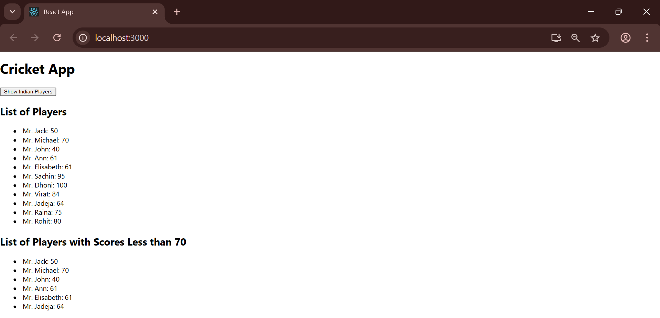

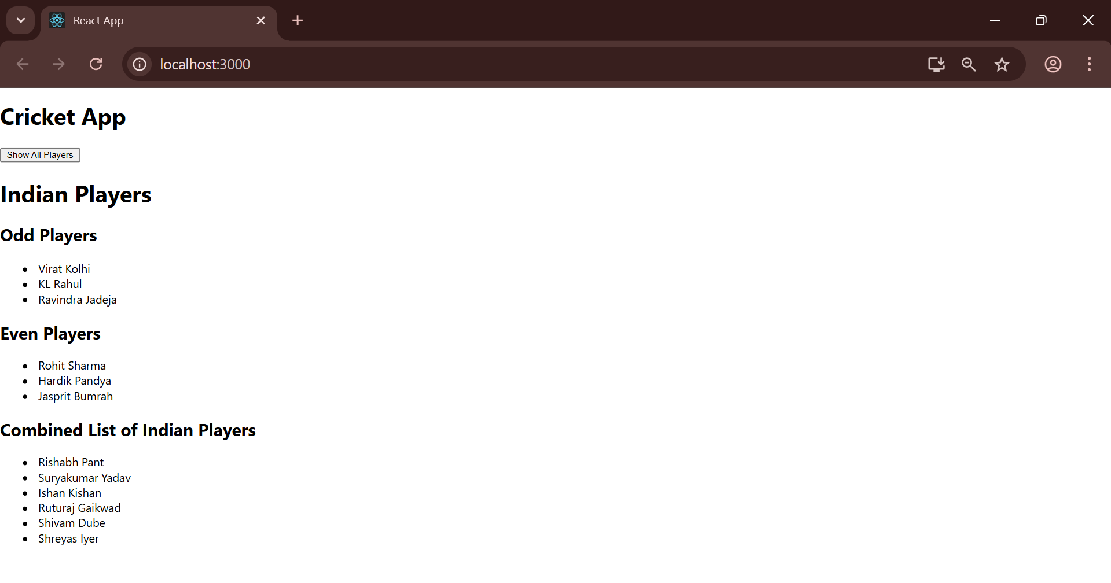

10) Create a React Application named “officespacerentalapp” which uses React JSX to create elements, attributes and renders DOM to display the page.

Create an element to display the heading of the page.

Attribute to display the image of the office space

Create an object of office to display the details like Name, Rent and Address.

Create a list of Object and loop through the office space item to display more data.

To apply Css, Display the color of the Rent in Red if it’s below 60000 and in Green if it’s above 60000.

App.css:

.App {

  text-align: center;

}

.textRed {

  color: red;

}

.textGreen {

  color: green;

}

App.js:

import React from 'react';

import './App.css';

import officeImage from './office.jpg';

function App() {

  const offices = [

    { Name: "DBS", Rent: 50000, Address: 'Chennai' },

    { Name: "TCS", Rent: 75000, Address: 'Bangalore' },

    { Name: "Wipro", Rent: 55000, Address: 'Pune' }

  ];

  return (

    <div className="App">

      <h1>Office Space, at Affordable Range</h1>

      {offices.map((office, index) => (

        <div key={index} className="office-details">

          <img src={officeImage} width="25%" height="25%" alt="Office Space"/>

          <h2>Name: {office.Name}</h2>

          { }

          <h3 className={office.Rent <= 60000 ? 'textRed' : 'textGreen'}>

            Rent: Rs. {office.Rent}

          </h3>

          <h3>Address: {office.Address}</h3>

        </div>

      ))}

    </div>

  );

}

export default App;

Web Screenshot:

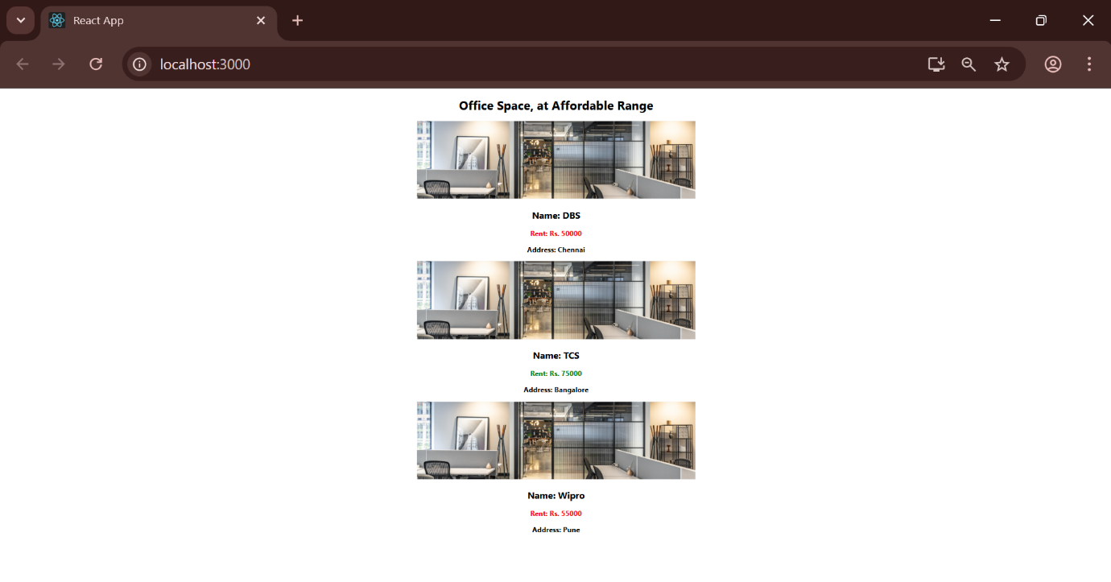

11) Create a React Application “eventexamplesapp” to handle various events of the form elements in HTML.

1. Create “Increment” button to increase the value of the counter and “Decrement” button to decrease the value of the counter. The “Increase” button should invoke multiple methods.
   1. To increment the value
   2. Say Hello followed by a static message.

1. Create a button “Say Welcome” which invokes the function which takes “welcome” as an argument.

1. Create a button which invokes synthetic event “OnPress” which display “I was clicked”

Create a “CurrencyConvertor” component which will convert the Indian Rupees to Euro when the Convert button is clicked.

Handle the Click event of the button to invoke the handleSubmit event and handle the conversion of the euro to rupees.

CurrencyConverter.js:

import React, { useState } from 'react';

const CurrencyConvertor = () => {

  const [rupees, setRupees] = useState(0);

  const [euros, setEuros] = useState(0);

  const exchangeRate = 0.0100;

  const handleRupeesChange = (e) => {

    setRupees(e.target.value);

  };

  const handleSubmit = (e) => {

    e.preventDefault();

    const convertedEuros = rupees \* exchangeRate;

    setEuros(convertedEuros.toFixed(2));  };

  return (

    <div>

      <h2>Currency Convertor (INR to EUR)</h2>

      <form onSubmit={handleSubmit}>

        <label>

          Indian Rupees:

          <input

            type="number"

            value={rupees}

            onChange={handleRupeesChange}

          />

        </label>

        <button type="submit">Convert</button>

      </form>

      <h3>{rupees} INR is approximately {euros} EUR</h3>

    </div>

  );

};

export default CurrencyConvertor;

App.css:

body {

  margin: 0;

  font-family: -apple-system, BlinkMacSystemFont, 'Segoe UI', 'Roboto', 'Oxygen',

    'Ubuntu', 'Cantarell', 'Fira Sans', 'Droid Sans', 'Helvetica Neue',

    sans-serif;

  -webkit-font-smoothing: antialiased;

  -moz-osx-font-smoothing: grayscale;

}

code {

  font-family: source-code-pro, Menlo, Monaco, Consolas, 'Courier New',

    monospace;

}

App.js:

import React, { useState } from 'react';

import CurrencyConvertor from './CurrencyConverter'; import './App.css';

function App() {

  const [count, setCount] = useState(0);

  const handleIncrement = () => {

    setCount(prevCount => prevCount + 1);

  };

  const handleDecrement = () => {

    setCount(prevCount => prevCount - 1);

  };

  const handleMultipleActions = () => {

    setCount(prevCount => prevCount + 1);

    alert('Hello! You just increased the count.');

  };

  const sayWelcome = (message) => {

    alert(message);

  };

  const handlePress = (e) => {

    console.log('Synthetic Event Object:', e);

    alert('Button pressed!');

  };

  return (

    <div className="flex flex-col items-center justify-center min-h-screen bg-gray-100 p-4">

      { }

      <h1 className="text-4xl font-bold mb-8 text-gray-800">React Event Handling Examples</h1>

      { }

      <div className="bg-white p-8 rounded-lg shadow-md w-full max-w-md mb-6 text-center">

        <h2 className="text-2xl font-semibold mb-4">Counter</h2>

        <h1 className="text-5xl font-bold mb-4 text-blue-600">{count}</h1>

        <div className="flex justify-center space-x-4">

          <button

            onClick={handleIncrement}

            className="px-6 py-3 bg-green-500 text-white rounded-md hover:bg-green-600 focus:outline-none focus:ring-2 focus:ring-green-500 focus:ring-opacity-50 transition duration-300"

          >

            Increment

          </button>

          <button

            onClick={handleDecrement}

            className="px-6 py-3 bg-red-500 text-white rounded-md hover:bg-red-600 focus:outline-none focus:ring-2 focus:ring-red-500 focus:ring-opacity-50 transition duration-300"

          >

            Decrement

          </button>

        </div>

      </div>

      { }

      <div className="bg-white p-8 rounded-lg shadow-md w-full max-w-md text-center">

        <h2 className="text-2xl font-semibold mb-4">More Buttons</h2>

        <div className="flex flex-col space-y-4">

          <button

            onClick={handleMultipleActions}

            className="w-full px-6 py-3 bg-purple-500 text-white rounded-md hover:bg-purple-600 focus:outline-none focus:ring-2 focus:ring-purple-500 focus:ring-opacity-50 transition duration-300"

          >

            Increase & Say Hello

          </button>

          <button

            onClick={() => sayWelcome('Welcome to the event lab!')}

            className="w-full px-6 py-3 bg-yellow-500 text-white rounded-md hover:bg-yellow-600 focus:outline-none focus:ring-2 focus:ring-yellow-500 focus:ring-opacity-50 transition duration-300"

          >

            Say Welcome

          </button>

          <button

            onClick={handlePress}

            className="w-full px-6 py-3 bg-indigo-500 text-white rounded-md hover:bg-indigo-600 focus:outline-none focus:ring-2 focus:ring-indigo-500 focus:ring-opacity-50 transition duration-300"

          >

            OnPress (Simulated onClick)

          </button>

        </div>

      </div>

      <hr className="my-8 w-full max-w-md border-t-2 border-gray-300" />

      { }

      <div className="bg-white p-8 rounded-lg shadow-md w-full max-w-md">

        <CurrencyConvertor />

      </div>

    </div>

  );

}

export default App;

Web Screenshot:

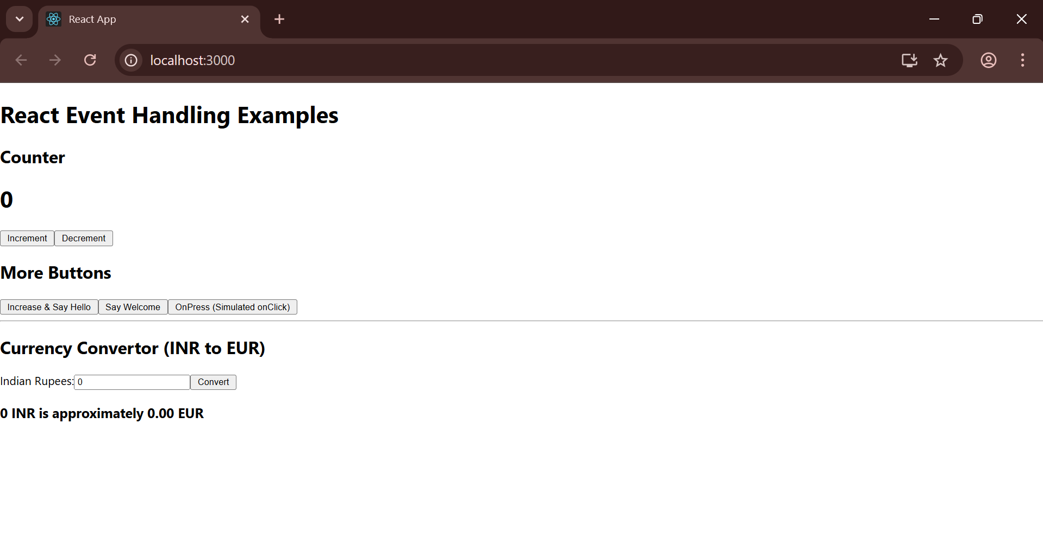

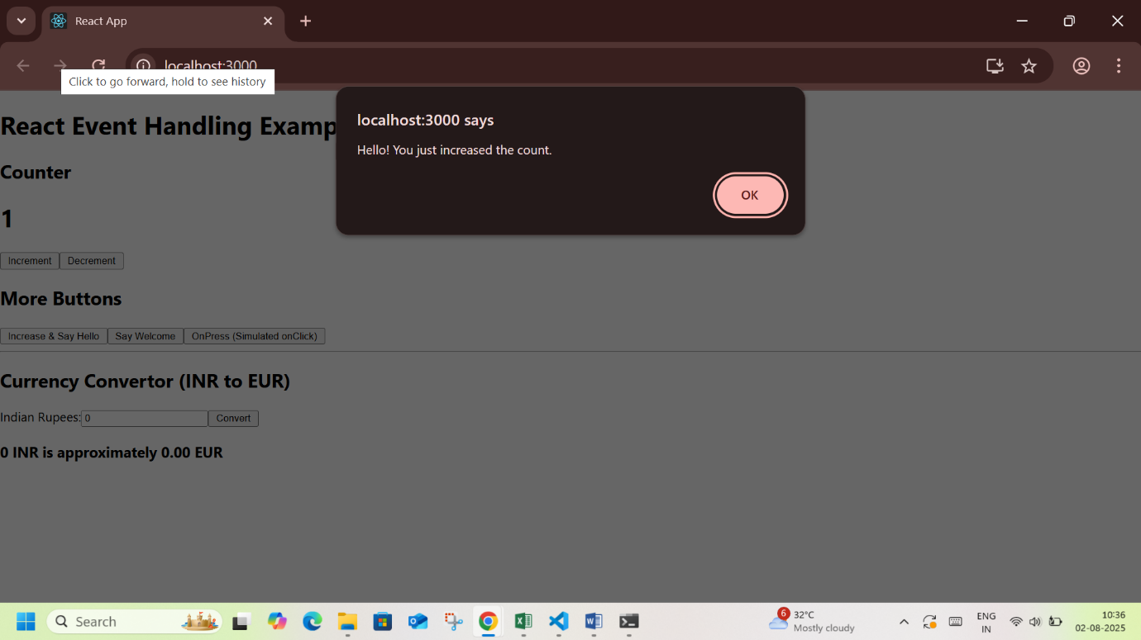

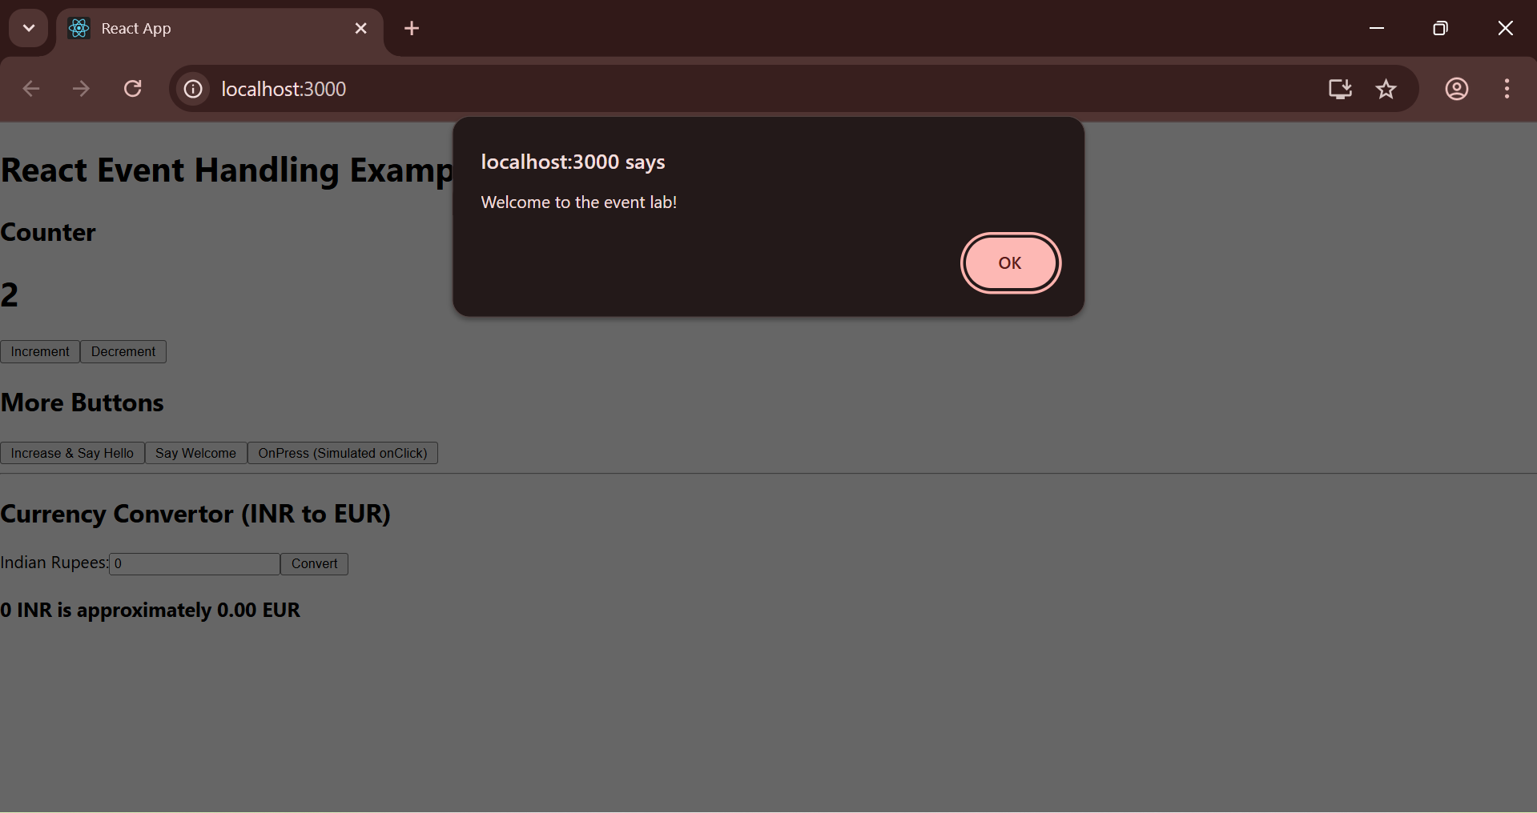

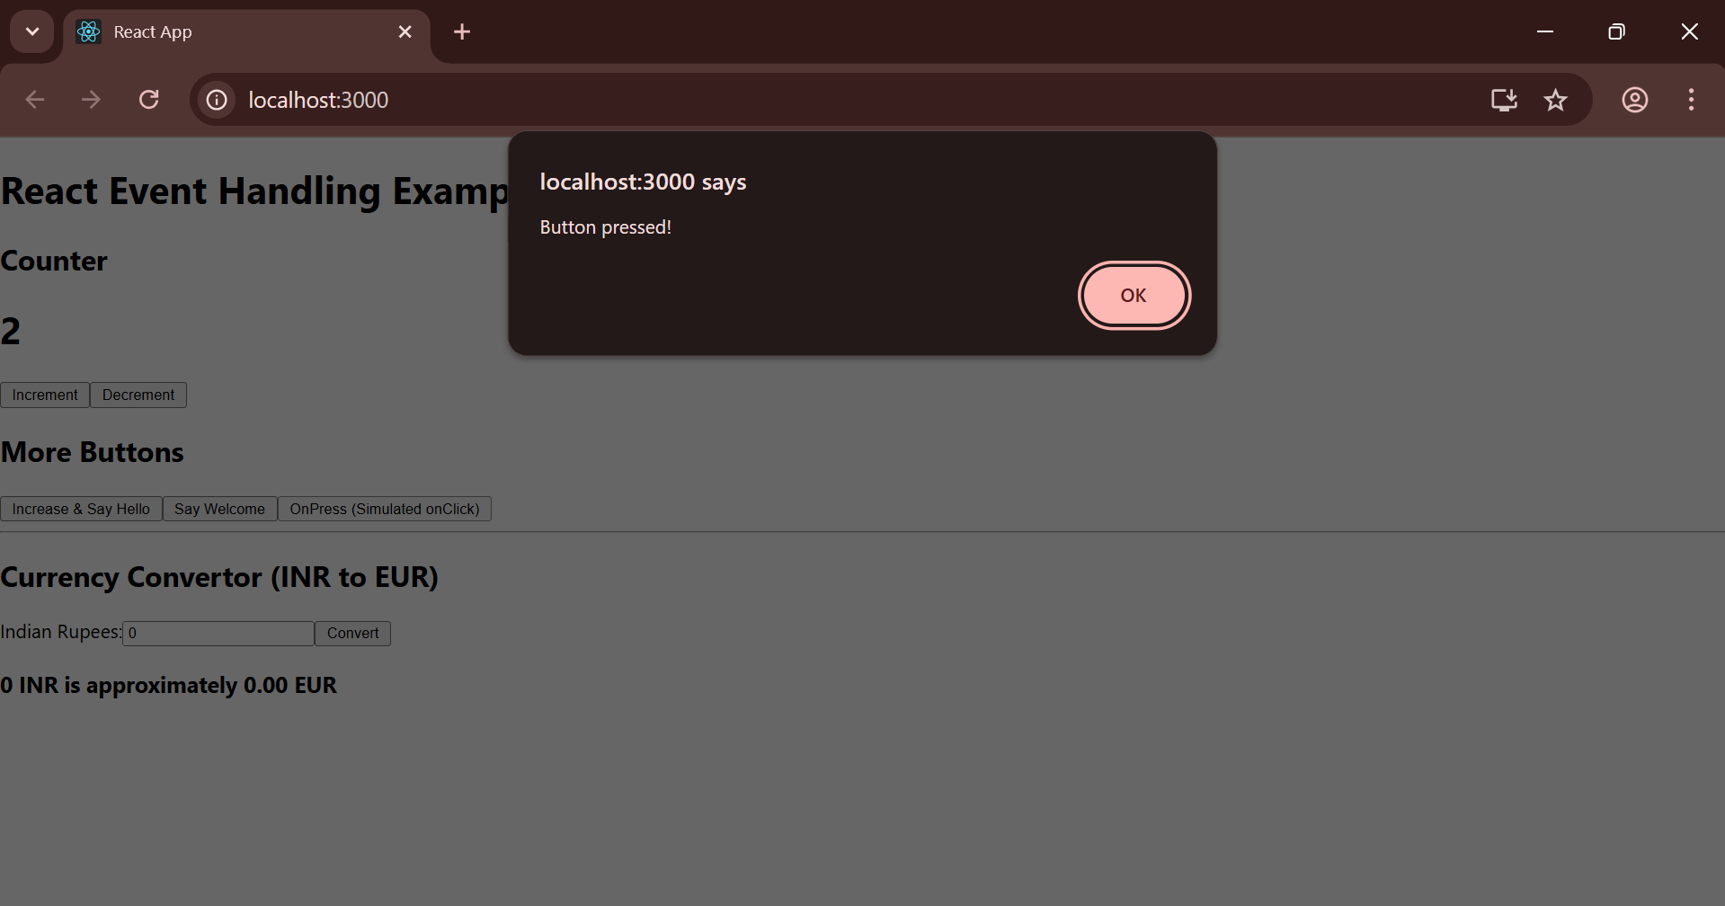

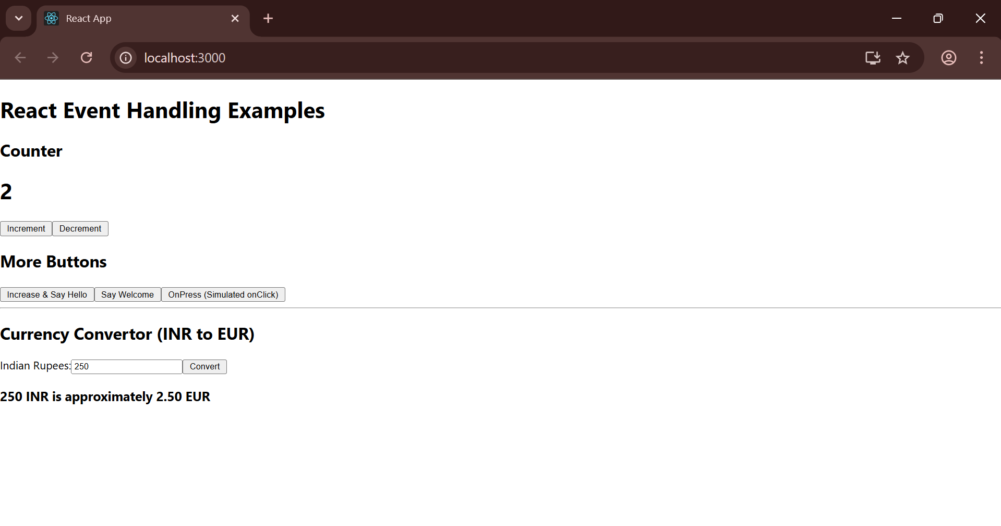

12) Create a React Application named “ticketbookingapp” where the guest user can browse the page where the flight details are displayed whereas the logged in user only can book tickets.

The Login and Logout buttons should accordingly display different pages. Once the user is logged in the User page should be displayed. When the user clicks on Logout, the Guest page should be displayed.

App.css:

.App {

  text-align: center;

  font-family: Arial, sans-serif;

  padding: 50px;

}

h1 {

  font-size: 2.5rem;

}

button {

  padding: 10px 20px;

  font-size: 1rem;

  cursor: pointer;

  border: 1px solid #ccc;

  border-radius: 5px;

  background-color: #f0f0f0;

  margin-top: 20px;

}

App.js:

import React, { useState } from 'react';

import './App.css';

function GuestGreeting() {

  return (

    <div>

      <h1>Please sign up.</h1>

      <p>Guest users can browse flight details.</p>

    </div>

  );

}

function UserGreeting() {

  return (

    <div>

      <h1>Welcome back!</h1>

      <p>Logged-in users can book tickets.</p>

    </div>

  );

}

function LoginButton(props) {

  return (

    <button onClick={props.onClick}>

      Login

    </button>

  );

}

function LogoutButton(props) {

  return (

    <button onClick={props.onClick}>

      Logout

    </button>

  );

}

function Greeting(props) {

  const isLoggedIn = props.isLoggedIn;

  if (isLoggedIn) {

    return <UserGreeting />;

  }

  return <GuestGreeting />;

}

function App() {

  const [isLoggedIn, setIsLoggedIn] = useState(false);

  const handleLoginClick = () => {

    setIsLoggedIn(true);

  };

  const handleLogoutClick = () => {

    setIsLoggedIn(false);

  };

  let button;

  if (isLoggedIn) {

    button = <LogoutButton onClick={handleLogoutClick} />;

  } else {

    button = <LoginButton onClick={handleLoginClick} />;

  }

  return (

    <div className="App">

      <Greeting isLoggedIn={isLoggedIn} />

      {button}

    </div>

  );

}

export default App;

Web Screenshot:

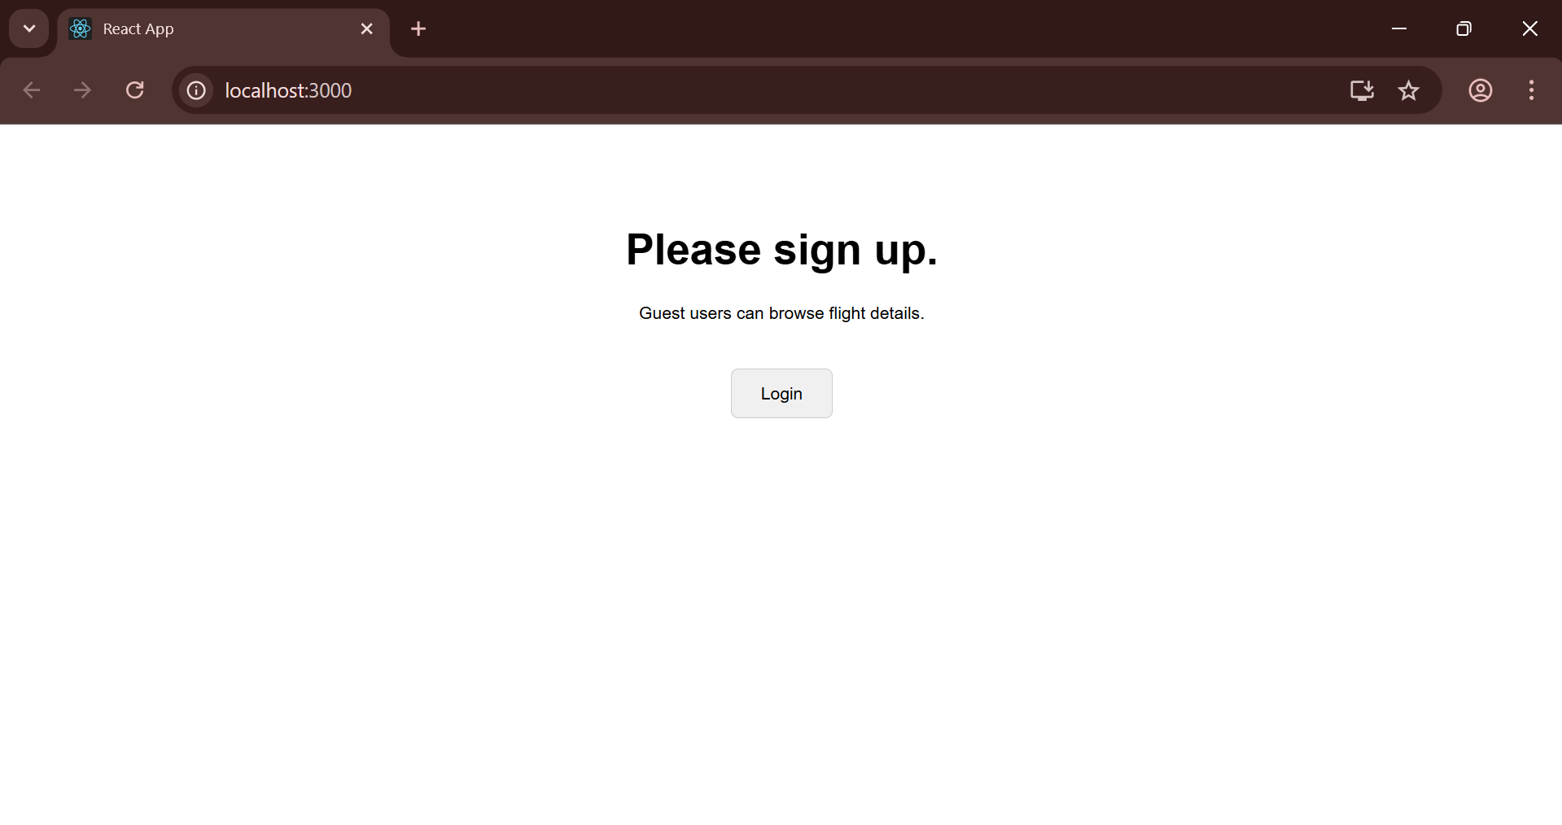

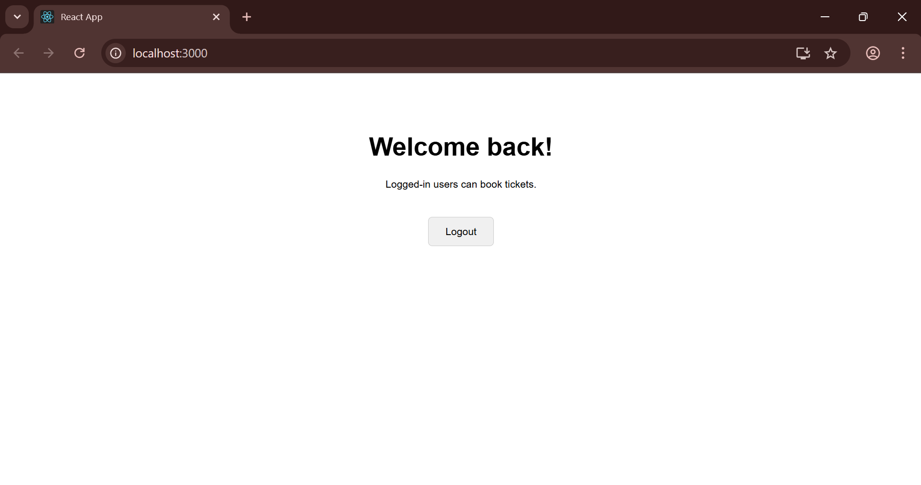

13) Create a React App named “bloggerapp” in with 3 components.

1. Book Details
2. Blog Details
3. Course Details

Implement this with as many ways possible of Conditional Rendering.

Data.js:

// src/data.js

export const books = [

  { id: 101, bname: 'Master React', price: 699 },

  { id: 102, bname: 'Deep Dive Into Angular 11', price: 799 },

  { id: 103, bname: 'Mongo Essentials', price: 459 },

];

export const blogs = [

  { id: 201, title: 'React Learning', author: 'Stephen Biz', content: 'Welcome to learning React!' },

  { id: 202, title: 'Installation', author: 'Schewzdenier', content: 'You can install React from npm.' },

];

export const courses = [

  { id: 301, name: 'Angular', date: '4/5/2021' },

  { id: 302, name: 'React', date: '6/3/2020' },

];

App.css:

.App {

  text-align: center;

  font-family: Arial, sans-serif;

  padding: 20px;

}

.container {

  display: flex;

  justify-content: space-around;

  margin-top: 20px;

}

.details-section {

  border: 1px solid #ccc;

  padding: 20px;

  border-radius: 8px;

  width: 30%;

  text-align: left;

}

.details-section h1 {

  font-size: 1.5rem;

  border-bottom: 2px solid green;

  padding-bottom: 10px;

}

App.js:

import React from 'react';

import './App.css';

import { books, blogs, courses } from './data';

function BookDetails() {

  return (

    <div className="details-section">

      <h1>Book Details</h1>

      <ul>

        {books.map(book => (

          <div key={book.id}>

            <h3>{book.bname}</h3>

            <h4>{book.price}</h4>

          </div>

        ))}

      </ul>

    </div>

  );

}

function BlogDetails() {

  return (

    <div className="details-section">

      <h1>Blog Details</h1>

      <ul>

        {blogs.map(blog => (

          <div key={blog.id}>

            <h3>{blog.title}</h3>

            <h4>{blog.author}</h4>

            <p>{blog.content}</p>

          </div>

        ))}

      </ul>

    </div>

  );

}

function CourseDetails() {

  return (

    <div className="details-section">

      <h1>Course Details</h1>

      <ul>

        {courses.map(course => (

          <div key={course.id}>

            <h3>{course.name}</h3>

            <h4>{course.date}</h4>

          </div>

        ))}

      </ul>

    </div>

  );

}

function App() {

  return (

    <div className="App">

      <div className="container">

        <BookDetails />

        <BlogDetails />

        <CourseDetails />

      </div>

    </div>

  );

}

export default App;

Web Screenshot:

